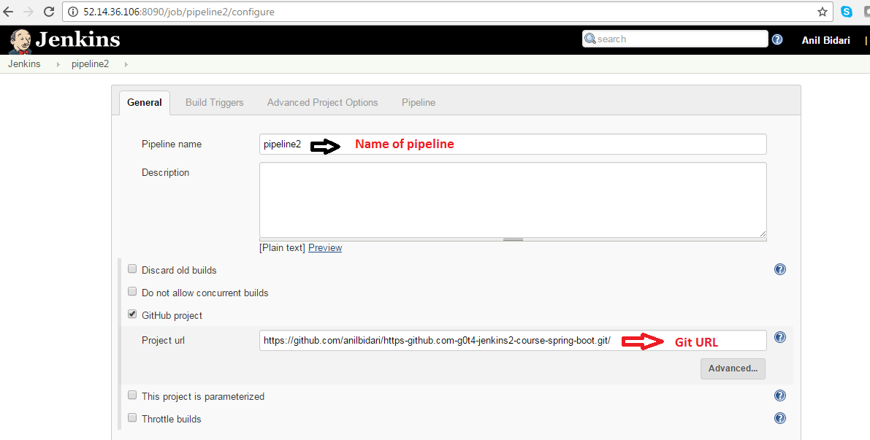

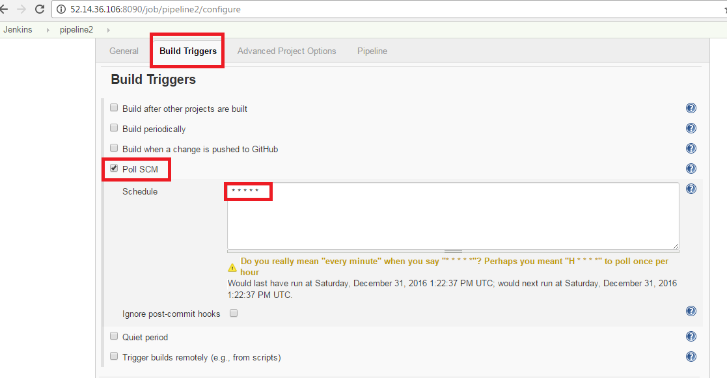

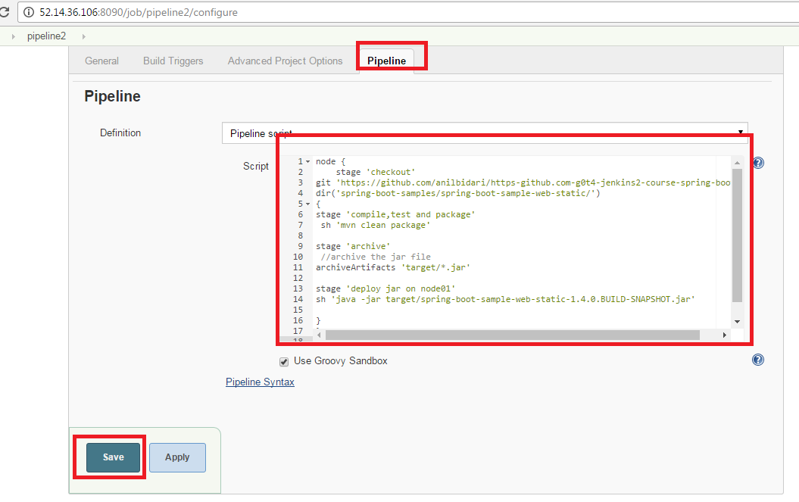

node {

stage 'checkout'

git 'https://github.com/anilbidari/https-github.com-g0t4-jenkins2-course-spring-boot.git'

dir('spring-boot-samples/spring-boot-sample-web-static/')

{

stage 'compile,test and package'

sh 'mvn clean package'

stage 'archive'

//archive the jar file

archiveArtifacts 'target/\*.jar'

stage 'deploy jar on node01'

sh 'java -jar target/spring-boot-sample-web-static-1.4.0.BUILD-SNAPSHOT.jar'

}

}